PROGRAM:

import pandas as pd  
import numpy as np  
import matplotlib.pyplot as plt  
from tensorflow.keras.preprocessing.text import Tokenizer  
from tensorflow.keras.preprocessing.sequence import pad_sequences  
from tensorflow.keras.models import Sequential  
from tensorflow.keras.layers import LSTM, Dense, Dropout, SpatialDropout1D, Embedding  
  
# Create a dummy dataset  
data = {  
 'text': [  
 "I loved the flight, it was amazing!",  
 "The flight was okay, nothing special.",  
 "Worst experience ever, flight delayed and rude staff.",  
 "The flight attendants were friendly and helpful.",  
 "Terrible service, I'll never fly with this airline again."  
 ],  
 'airline_sentiment': [  
 'positive',  
 'neutral',  
 'negative',  
 'positive',  
 'negative'  
 ]  
}  
  
# Create DataFrame  
df = pd.DataFrame(data)  
  
# Filter out neutral sentiment  
review_df = df[df['airline_sentiment'] != 'neutral']  
  
# Tokenize the text  
tweet = review_df.text.values  
tokenizer = Tokenizer(num_words=5000)  
tokenizer.fit_on_texts(tweet)  
  
# Determine vocabulary size  
vocab_size = len(tokenizer.word_index) + 1  
  
# Encode and pad sequences  
encoded_docs = tokenizer.texts_to_sequences(tweet)  
padded_sequence = pad_sequences(encoded_docs, maxlen=20)  
  
# Model architecture  
embedding_vector_length = 32  
model = Sequential()  
model.add(Embedding(vocab_size, embedding_vector_length, input_length=20))  
model.add(SpatialDropout1D(0.25))  
model.add(LSTM(50, dropout=0.5, recurrent_dropout=0.5))  
model.add(Dropout(0.2))  
model.add(Dense(1, activation='sigmoid'))  
model.compile(loss='binary_crossentropy', optimizer='adam', metrics=['accuracy'])  
  
# Model summary  
print(model.summary())  
  
# Model training  
sentiment_label = review_df.airline_sentiment.factorize()  
history = model.fit(padded_sequence, sentiment_label[0], validation_split=0.2, epochs=5, batch_size=32)  
  
# Plot accuracy  
plt.plot(history.history['accuracy'], label='acc')  
plt.plot(history.history['val_accuracy'], label='val_acc')  
plt.legend()  
plt.savefig("Accuracy_plot.jpg")  
plt.show()  
  
# Plot loss  
plt.plot(history.history['loss'], label='loss')  
plt.plot(history.history['val_loss'], label='val_loss')  
plt.legend()  
plt.savefig("Loss_plot.jpg")  
plt.show()  
  
# Prediction function  
def predict_sentiment(text):  
 tw = tokenizer.texts_to_sequences([text])  
 tw = pad_sequences(tw, maxlen=20)  
 prediction = int(model.predict(tw).round().item())  
 print("Predicted label: ", sentiment_label[1][prediction])  
  
# Test sentences  
test_sentence1 = "I enjoyed my journey on this flight."  
predict_sentiment(test_sentence1)  
  
test_sentence2 = "This is the worst flight experience of my life!"  
predict_sentiment(test_sentence2)

**OUTPUT:**

Model: "sequential_1"  
_________________________________________________________________  
 Layer (type) Output Shape Param #   
=================================================================  
 embedding_1 (Embedding) (None, 20, 32) 896   
   
 spatial_dropout1d_1 (Spati (None, 20, 32) 0   
 alDropout1D)   
   
 lstm_1 (LSTM) (None, 50) 16600   
   
 dropout_1 (Dropout) (None, 50) 0   
   
 dense_1 (Dense) (None, 1) 51   
   
=================================================================  
Total params: 17547 (68.54 KB)  
Trainable params: 17547 (68.54 KB)  
Non-trainable params: 0 (0.00 Byte)  
_________________________________________________________________  
None  
Epoch 1/5  
1/1 [==============================] - 4s 4s/step - loss: 0.6866 - accuracy: 1.0000 - val_loss: 0.6945 - val_accuracy: 0.0000e+00  
Epoch 2/5  
1/1 [==============================] - 0s 52ms/step - loss: 0.6875 - accuracy: 0.6667 - val_loss: 0.6976 - val_accuracy: 0.0000e+00  
Epoch 3/5  
1/1 [==============================] - 0s 53ms/step - loss: 0.6905 - accuracy: 0.3333 - val_loss: 0.7011 - val_accuracy: 0.0000e+00  
Epoch 4/5  
1/1 [==============================] - 0s 52ms/step - loss: 0.6846 - accuracy: 0.6667 - val_loss: 0.7046 - val_accuracy: 0.0000e+00  
Epoch 5/5  
1/1 [==============================] - 0s 62ms/step - loss: 0.6800 - accuracy: 0.6667 - val_loss: 0.7082 - val_accuracy: 0.0000e+00

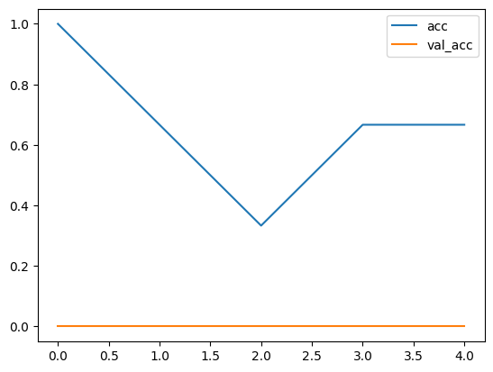

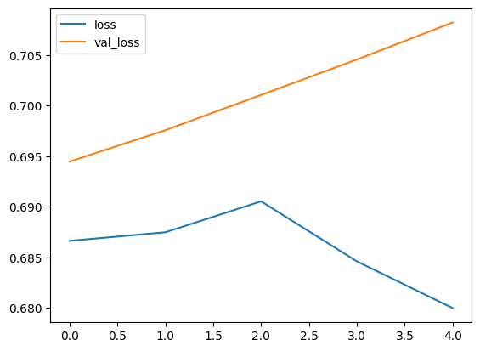

1/1 [==============================] - 0s 240ms/step  
Predicted label: positive  
1/1 [==============================] - 0s 20ms/step  
Predicted label: positive